臥式囊袋泡沫原液槽
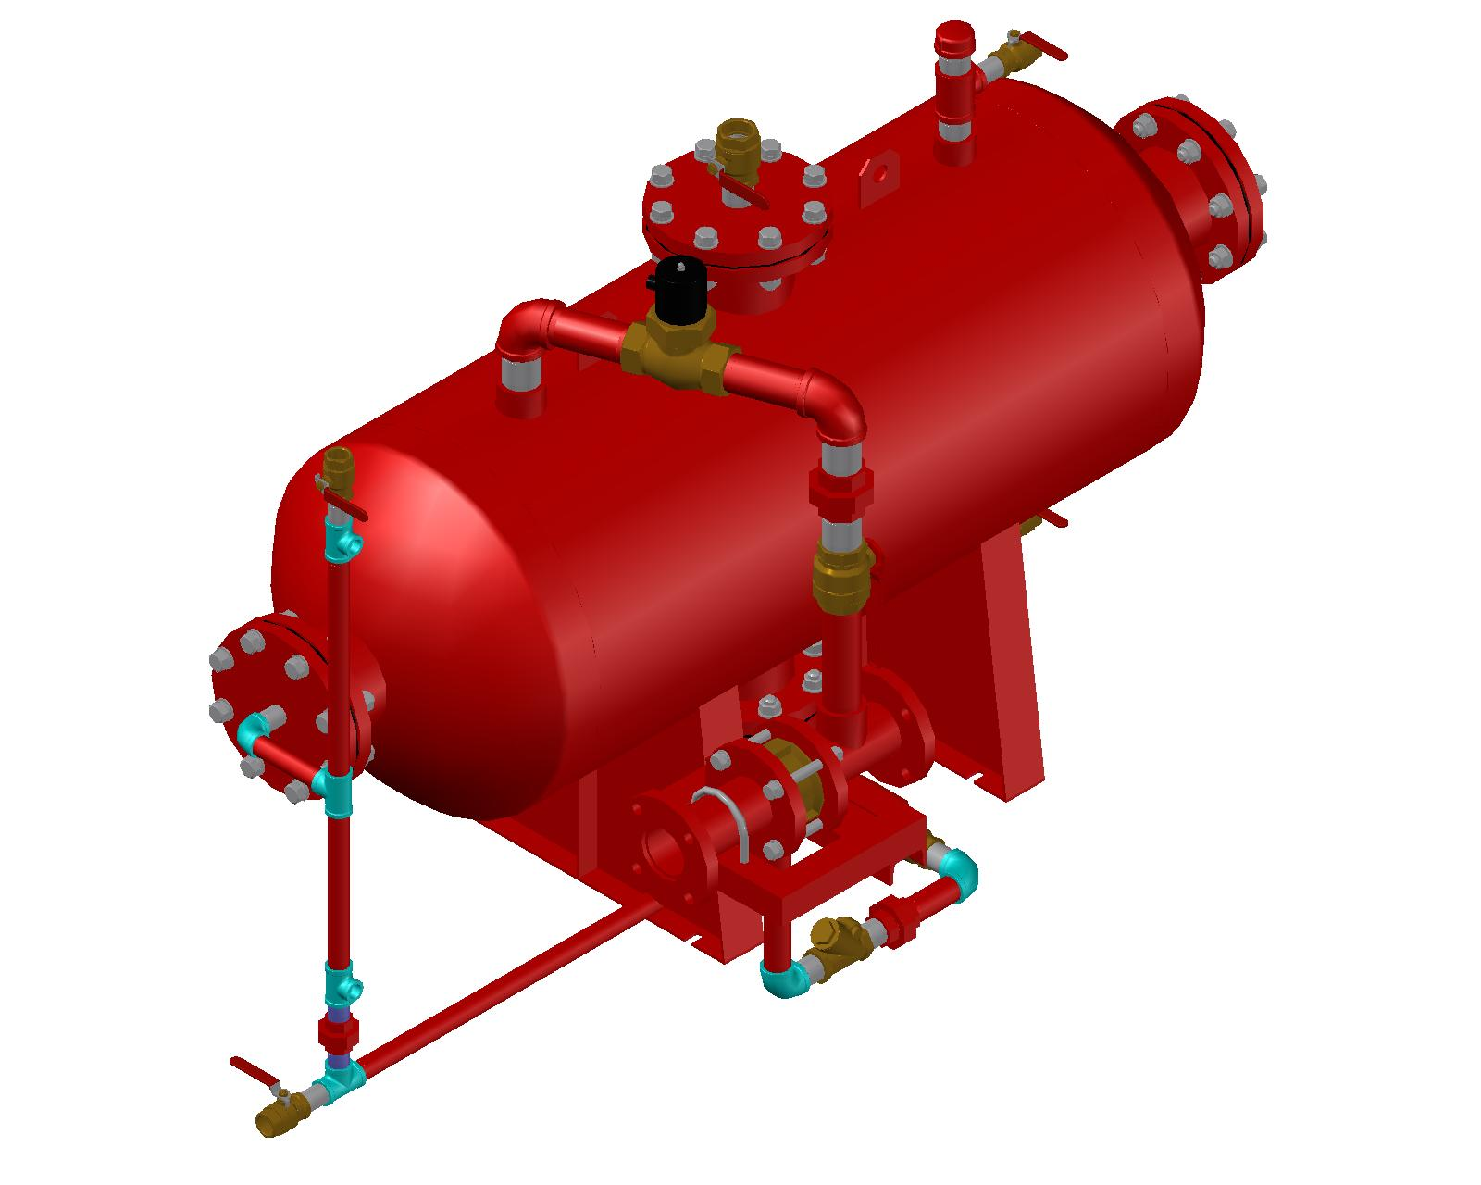

- 產品介紹
- 泡沫（ 初期稱為機械泡沫）自1 9 3 0 年首次作為滅火藥劑使用後，數十年來已發展成為滅火設備的主流之一。
- 在消防上使用的泡沫滅火劑係一種經由泡-水溶液結合空氣發泡後產生的泡沫。

其主要滅火方式係在易燃和可燃性液體上形成覆蓋層， 以隔絕空氣並冷卻燃燒物達到滅火目的，同時抑制易燃性氣體形成防止復燃的可能性，對暴露於火場鄰近的區域提供了一定程度的保護。
- 型號
  - WA-FT
- 材質
  - 槽體 – A-285c or SS400 or SUS304
  - 腳座 — JIS SS400／SB410 or ASTM A285-C or SUS304
  - 泡沫袋 –NEOPRENE (新平橡膠)。
  - 內外層NEOPRENE (新平橡膠)尺寸各0.35mm，中層為840(0.3mm)丹尼之尼龍布，厚度共1mm。
  - 法蘭 – ASTM A105 ANSI 150# RF/FF or JIS 10K。
  - 配管 – ASTM A106-B。
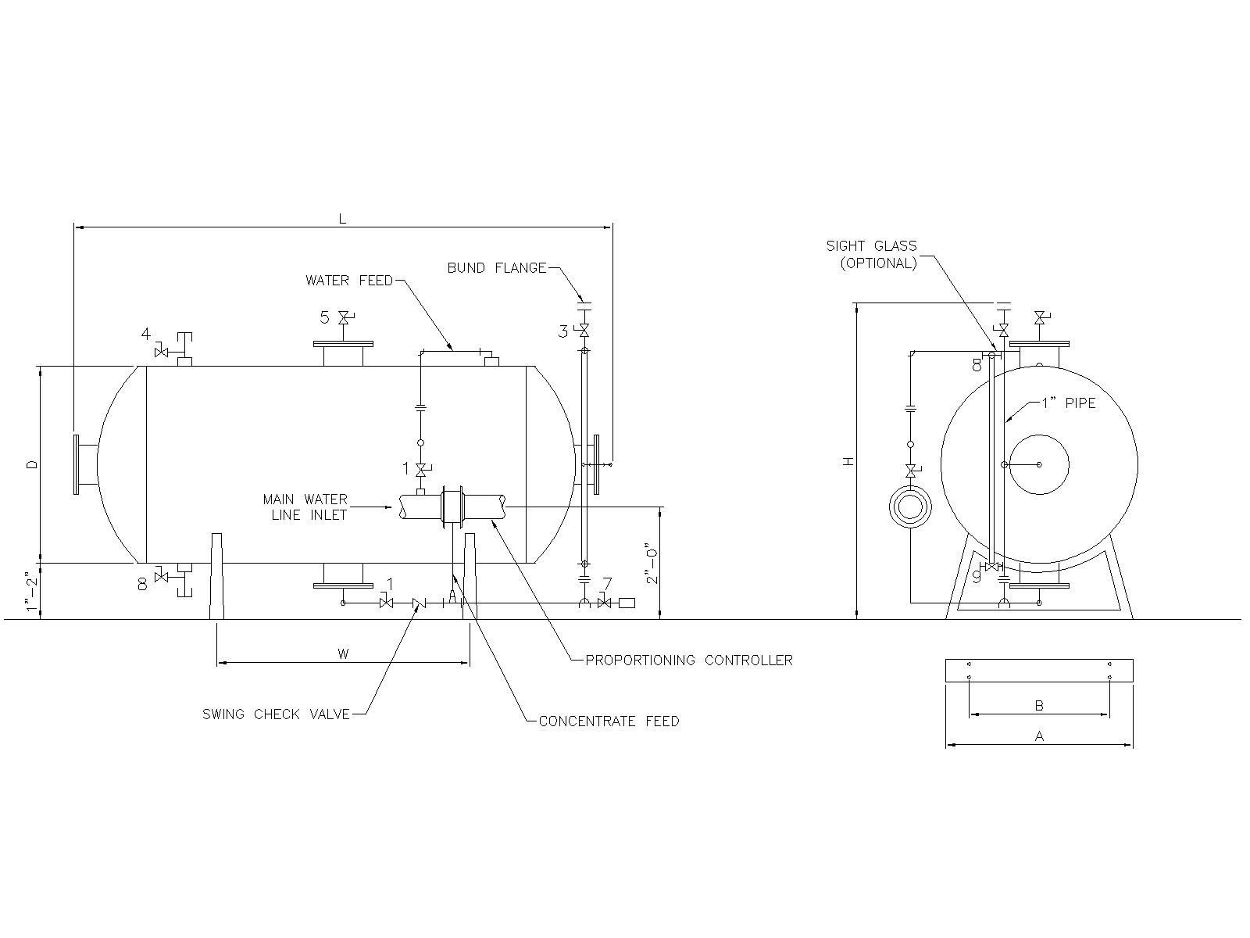
Capacity |  | L | H | D | W | A | B | C | G | Weight (Approx)
Gal. | Litres |  |  |  |  |  |  |  |  | Lbs. | Kgs.
50 | 189 | 1499 | 1156 | 508 | 356 | 508 | 356 | 45 | 15 | 307 | 139
100 | 379 | 1981 | 1257 | 610 | 584 | 610 | 457 | 45 | 15 | 446 | 202
150 | 568 | 1956 | 1410 | 762 | 508 | 762 | 559 | 60 | 15 | 659 | 299
200 | 757 | 2413 | 1410 | 762 | 940 | 762 | 559 | 60 | 15 | 774 | 351
300 | 1136 | 2464 | 1257 | 914 | 965 | 864 | 660 | 60 | 15 | 1001 | 454
400 | 1514 | 2337 | 1562 | 1067 | 889 | 1016 | 762 | 70 | 18 | 1323 | 602
500 | 1893 | 2921 | 1715 | 1067 | 1372 | 1016 | 762 | 70 | 18 | 1560 | 708
600 | 2271 | 2769 | 1715 | 1219 | 1168 | 1118 | 864 | 70 | 18 | 2040 | 925
700 | 2650 | 3124 | 2019 | 1219 | 1524 | 1118 | 864 | 70 | 18 | 2280 | 1034
800 | 3028 | 3454 | 1867 | 1219 | 1854 | 1118 | 864 | 70 | 18 | 2492 | 1130
900 | 3047 | 3810 | 1867 | 1219 | 2210 | 1118 | 864 | 70 | 18 | 2683 | 1217
1000 | 3785 | 4166 | 1867 | 1219 | 2565 | 1118 | 864 | 70 | 18 | 2955 | 1340
1100 | 4164 | 4547 | 1867 | 1219 | 3048 | 1118 | 864 | 70 | 18 | 3197 | 1450
1200 | 4542 | 4902 | 1867 | 1219 | 3404 | 1118 | 864 | 70 | 18 | 3420 | 1551
1300 | 4921 | 3607 | 2172 | 1524 | 1905 | 1372 | 1118 | 90 | 18 | 3917 | 1777
1400 | 5299 | 3797 | 2172 | 1524 | 2134 | 1372 | 1118 | 90 | 18 | 4135 | 1876
1500 | 5678 | 4064 | 2172 | 1524 | 2362 | 1372 | 1118 | 90 | 18 | 4358 | 1977
2000 | 7571 | 4064 | 2172 | 1829 | 2362 | 1676 | 1372 | 108 | 18 | 5020 | 2282
2500 | 9463 | 4699 | 2477 | 1829 | 2362 | 1676 | 1372 | 108 | 18 | 6390 | 2898
3000 | 11355 | 5537 | 2477 | 1829 | 2743 | 1676 | 1372 | 108 | 18 | 7204 | 3269
註:長度單位為mm

